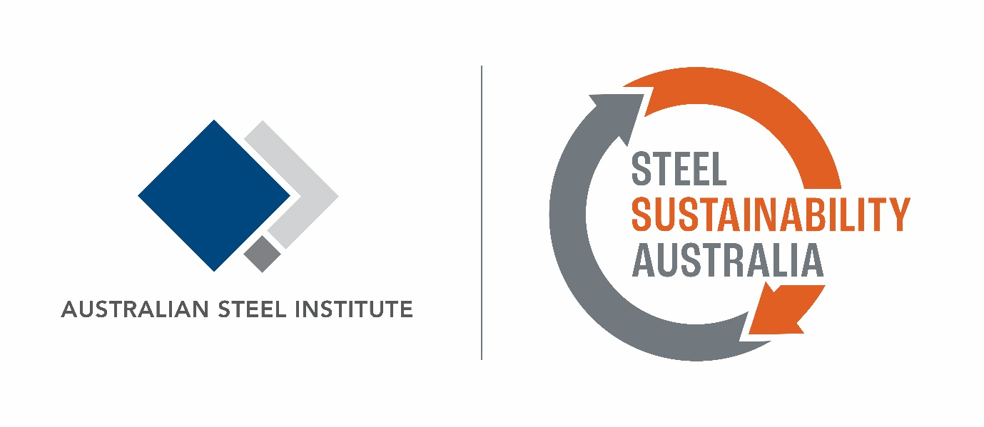

Sustainability Specification for Steel

Revision | Date | Issue Purpose | Author | Reviewer
1.0 | 3/5/2023 | For use | SSA | ASI

The Australian Steel Institute (the owner and operator of Steel Sustainability Australia) recommends the following sustainability related specification when procuring any steel for construction projects in Australia.

It is designed for specifiers and procurers of steel to use in their procurement contract or project specifications.

Steel purchased
All semi-finished steel purchased must be either:
- Sourced from steelmakers who are verified to meet the requirements under 4.1 Steel Supply Sourcing of the Steel Sustainability Australia (SSA) Certification Program – that is, a SSA verified steel supplier. Contractor must provide a valid SSA Verified Supplier Certificate; or
- Sourced from steelmakers who have a product-specific Environmental Product Declaration (EPD) for their steel product/s AND are certified to any of the following certification schemes;
- GECA Steel and Steel Products (SSP v1.0i-2019), or
- ResponsibleSteel™ Standard (v 1.1 or v2.0), or
- Global GreenTag International Standard v4 (Green Rate - Level A), or
- Any other scheme listed as a recognised initiative under the Green Building Council of Australia Responsible Product Framework that assesses ESG sustainability performance in steelmaking operations

Contractor must provide evidence of certification to any of the above schemes, together with Environmental Product Declarations (EPDs) for all products manufactured by the steelmaker that are included in the project.

Steelwork
Fabricated, manufactured, or processed steelwork must be:
- Supplied from steelwork fabricators, reinforcing processors, roll formers, manufacturers or other fabricated or processed steelwork provider whose facilities are certified to the ASI Steel Sustainability Australia (SSA) Certification Program and are listed as certified on the SSA Supplier Listing on the SSA website (see https://www.steelsustainability.com.au/supplier-listing).

Contractor must provide a copy of a valid SSA Certificate of Compliance listing the site/s that manufactured the products procured for the project.

For any questions regarding the specification, please contact ASI - SSA

Ph: 02 8748 0180
Email: ssa@steel.org.au

